**Car spare parts and service provider Platform**

**A. B. Bhawin1, Mrs. A. Sathiya Priya2,**

1Department of Information Technology, Dr.N.G.P. Arts and Science College, Coimbatore, Tamil Nadu, India

bhawinbhawin4@gmail.com1

2ASSISTANT Professor, Department of Information Technology, Dr.N.G.P. Arts and Science College, Coimbatore, Tamil Nadu, India

Sathiyapriya1327@gmail.com2

**ABSTRACT**

The intention of the proposed project is to create an internet-based and mobile application that links consumers and auto spare parts merchants, providing a complete solution for selling both brand-new and used parts and streamlining the repair processes. Customers can find and buy components quickly because to the platform's advanced search filters, real-time inventory updates, and user-friendly interface. While integrated geolocation services locate local dealers and mechanics, dealers may display their items with thorough descriptions to guarantee exposure and transparency. Part compatibility is guaranteed by an intelligent recommendation system, and quality assurance is upheld by a review mechanism. The app is a one-stop shop for auto maintenance since it also has a mechanic booking function that lets users hire a professional to help with installation.

**Keywords:** Geolocation services, Maintenance , Dealers and mechanics, Auto spare parts

1. **INTRODUCTION**

[1] The car industry is now leading the transport sector, where vehicle maintenance and spare part acquisition are key in an attempt to make it efficient and long-lasting. But consumers are usually confronted with a myriad of issues when trying to obtain some spare parts, such as poor suppliers, unavailability of new and second-hand parts, and poorquality installation services. In a bid to address these challenges, the ongoing project seeks to create a Car Spare Parts and Service Provider Application, which is a cross-platform application that will facilitate easy access to spare parts and repair services.  
  
The overall objective of this app is to provide a comprehensive and friendly platform linking customers with motor vehicle spare parts providers and mechanics. Through The implementation of state-of-the-art features such as live inventory tracking, geo-location software, and AI-driven recommendations, the app enhances the entire experience significantly by offering the potential for searching needed parts in real time and in real accuracy. The website further has a book function for mechanics through which they can book professional installation services right from the app. This project aims to transform the business of spare parts by addressing some of the significant issues, such as availability fragmentation, dealer invisibility, and low-quality expert installation services. Consumers can efficiently search and purchase spare parts and gain complete visibility of product listings, reviews, and prices from a central network. Dealers and mechanics also get to synchronize their services more effectively, thereby enhancing the accessibility and reliability of the business. The technologies used in this project are JavaScript (ES6+) for web and mobile app development, MySQL and Node.js for server-side app development, and Android Studio for deploying the mobile app. The application is meant to be deployed on both the web and mobile platforms, thereby achieving a broad range and availability to the users.

This journal provides an extensive walkthrough of the entire project development life cycle of the Car Spare Parts and Service Provider Application from the conceptual phase to system design, implementation, and testing. The primary goal of this project is to deliver an innovative solution that enhances convenience, efficiency, and reliability of the automobile aftermarket industry.

1. **PROBLEM STATEMENT**

The automobile business is the leading industry involved in the transport sector of the age of modern technology, where tens of millions of vehicles need ceaseless repairing and replacement of the spare parts. But the users always have a lot to undergo in searching some spare parts as well as good servicing agents. Currently, the spare part market is extremely fragmented, and this prevents the customers from accessing original spare parts, checking prices, and ordering competent installation services. This absence of a centralized platform leads to inefficiencies, frustration, and higher maintenance expenses for car owners. Existing Auto spare part sites don't support real-time inventory status, clean prices, and an effective purchasing process. Shoppers are often asked to traverse multiple stores or get unconfirmed web offers, which results in delays, invalid information, and losses. Technicians and the dealers also do not have a large consumer base as they gain little online exposure, limiting their business expansion possibility.

To address these challenges, this project suggests creating a Car Spare Parts and Service Provider App—a cross-platform app that brings customers, spare part dealers, and mechanics onto a single user-friendly platform. This app will make car spare part finding, buying, and fitting an easier task with transparency, efficiency, and trust for all the users.

1. **KEY CHALLENGES**

2] Segmented Marketplace:

Consumers are unable to find particular car spare parts, new or used, as there is no platform. In the absence of a systematic system, consumers have to perform tedious searches and doubt over part availability and quality.

Limited Dealer Visibility:

Most of such reliable mechanics and dealers go unrecommended because they have low visibility on the web, hence generating a challenge in reaching reliable service providers by customers. This constrains business growth for dealers but compels customers to seek word-of-mouth recommendations.

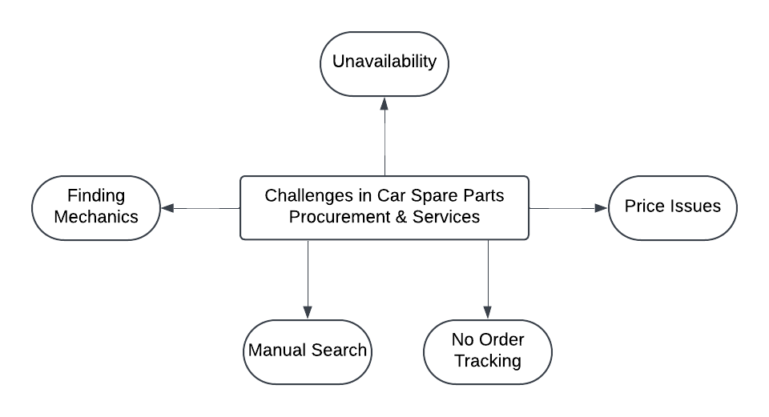

**Fig.1**

Poor Expert Installation Services:

Even when customers are able to obtain the spare parts they require, they are also not able to access professional installation. The lack of an efficient booking system leads to delays, inconvenience, and over-reliance on unscrupulous mechanics.

Poor Search and Inventory Management:

These websites do not give real-time updates of available stock, which frustrates customers who purchase out-of-stock parts. The lack of advanced search filters also does not give readily available compatible spare parts by vehicle specifications.

Trust and Transparency Issues:

Customers are discouraged from assuming the quality and purity of the parts since most vendors give incomplete or false information. The lack of a review and rating system makes it even more difficult.

1. **NEED FOR A SOLUTION**

The after-sales car business is a significant industry in the maintenance and longevity of automobiles but is basically unorganized and inefficient due to issues outlined in the problem statement. Spare part owners usually have a hard time finding spare parts, checking quality, comparing prices, and obtaining professional installation services. The same applies to mechanics and spare part dealers who also experience poor visibility and accessibility, thereby making it more difficult to reach prospective consumers.

* Unified Platform for Spare Parts and Service: Scattered availability of car spare parts due to absence of a centralized and exclusive digital marketplace leads consumers to utilize diversified sources, i.e., local shops, online postings, or third-party e-commerce websites, which do not necessarily ensure original services or true information. By developing a Car Spare Parts and Service Provider App, we are able to offer a one-stop solution that unifies spare part dealers, customers, and mechanics in an integrated and transparent manner.
* Improved Spare Parts Search and Discovery: It's a piece of cake to lose hours and feel frustrated searching for the proper spare parts, particularly to locate a particular brand, model, or used parts. Traditional searches involve visiting several dealerships, calling multiple dealerships, or searching through unstructured lists. This app will offer: Improved search filters to limit the results by car model, brand, type of part, price, and availability.AI-based recommendation engine to offer compatible spare part recommendations based on user browsing history and interest. Product detailed listings including product description, product images, and compatibility details to allow customers to make an informed choice. With all these features, the app will reduce search time by a huge percentage and ensure more accuracy in searching the right spare parts.
* Real-Time Inventory Updates for Improved Availability:One of the most important customer problems is to order a part and subsequently be informed that it is out of stock. Bricks-and-mortar dealerships and internet retailers will not maintain an up-to-date stock ledger, which will be time-consuming and inconvenient. The system to be implemented will allow dealers to update in real-time the stock levels so that customers can only see available parts. Reduce the average number of stock unavailability-led order cancellations. Provide an intelligent alert system to notify customers when the searched component comes back in stock. With the application of real-time inventory control, the app will optimize productivity and prevent delay in car repair.
* Enhanced Visibility and Business Expansion for Mechanics and Dealers:The majority of the local spare part dealers and mechanics employ traditional means of advertising like word of mouth, minidoor advertisements, or social media, which do not enable them to reach the masses. The app will provide dealers with an online interface through which they can list their products with description, images, price, and quantity. Enable mechanics to post their services, installation, repair, and customization. Make the customers allow their rating and reviewing of the mechanics and the dealers, to earn trust and credibility. Include geo-location suggestions that will enable the customers to view the proximity-based mechanics and the dealers nearby. This website will improve the business opportunities of dealers and the mechanics, by connecting them to the larger group outside their catchment area.
* Mechanic Simple Booking for Expert Installation Services:Spare part purchase is only half the equation—quality mechanic fitment is equally important. It is difficult for most customers to find trustworthy mechanics and are stuck with untested or inexperienced service personnel. The app will deliver an in-app booking feature where customers are able to book mechanic appointments within the app. A verified set of mechanics whose rating, review, and level of experience come to the foreground. The ease of choosing installation services at home, in a workshop, or at the dealer. By integrating booking of a mechanic with spare part purchase, the app dissuades customers from looking for installation services individually, offering a one-stop and convenient service.
* Safe and Clear Transactions:The majority of the customers do not want to purchase spare parts over the internet due to fraud, counterfeiting, and fear of misinformation. The app will establish trust and security by verified profiles of mechanics and dealers to ensure authenticity. A secure payment gateway and multi-payment capability like UPI, credit/debit cards, and cash-on-delivery. Detailed product information and images to minimize the possibility of receiving incorrect or fake parts. Customer service and conflict resolution, support in case of faulty parts or issues with service providers. By making transactions secure and transparent, the app will boost customer confidence and encourage increased usage.
* Geo-Location Services for Easy Access to Local Dealers and Services : The majority of car owners would prefer to purchase spare parts and receive services from locations within close proximity to reduce waiting time and additional shipping charges. The app will possess geo-location features to: Identify and recommend nearby spare part stores and mechanics in the vicinity of the user. Offer real-time directions to direct the customer to the closest service center or store. Facilitate support for location-based promotions and offers, offering customers price-saving deals. This feature will help in ease of access and convenience, enabling the customers to immediately locate the closest and most suitable services
* Review and Rating System for Encouraging Trust:Trust is a crucial issue for the auto aftermarket sector, especially in purchasing parts from unknown sources or hiring new mechanics. To cater to this need, the application will include a review and rating system by the users on mechanics, dealers, and spare parts Customer-reviewed feedback to enable users to make informed buying decisions. A highly rated mechanic and dealer filter option so that users view only decent service providers on their list. This will increase user transparency and trust and make the app a secure place to purchase and have their vehicles maintained.

1. **APP WORKFLOW**

The flowchart is the process of purchasing car spare parts and getting associated services within an integrated interface. The following is a step-by-step detailed explanation of the operation of the app.

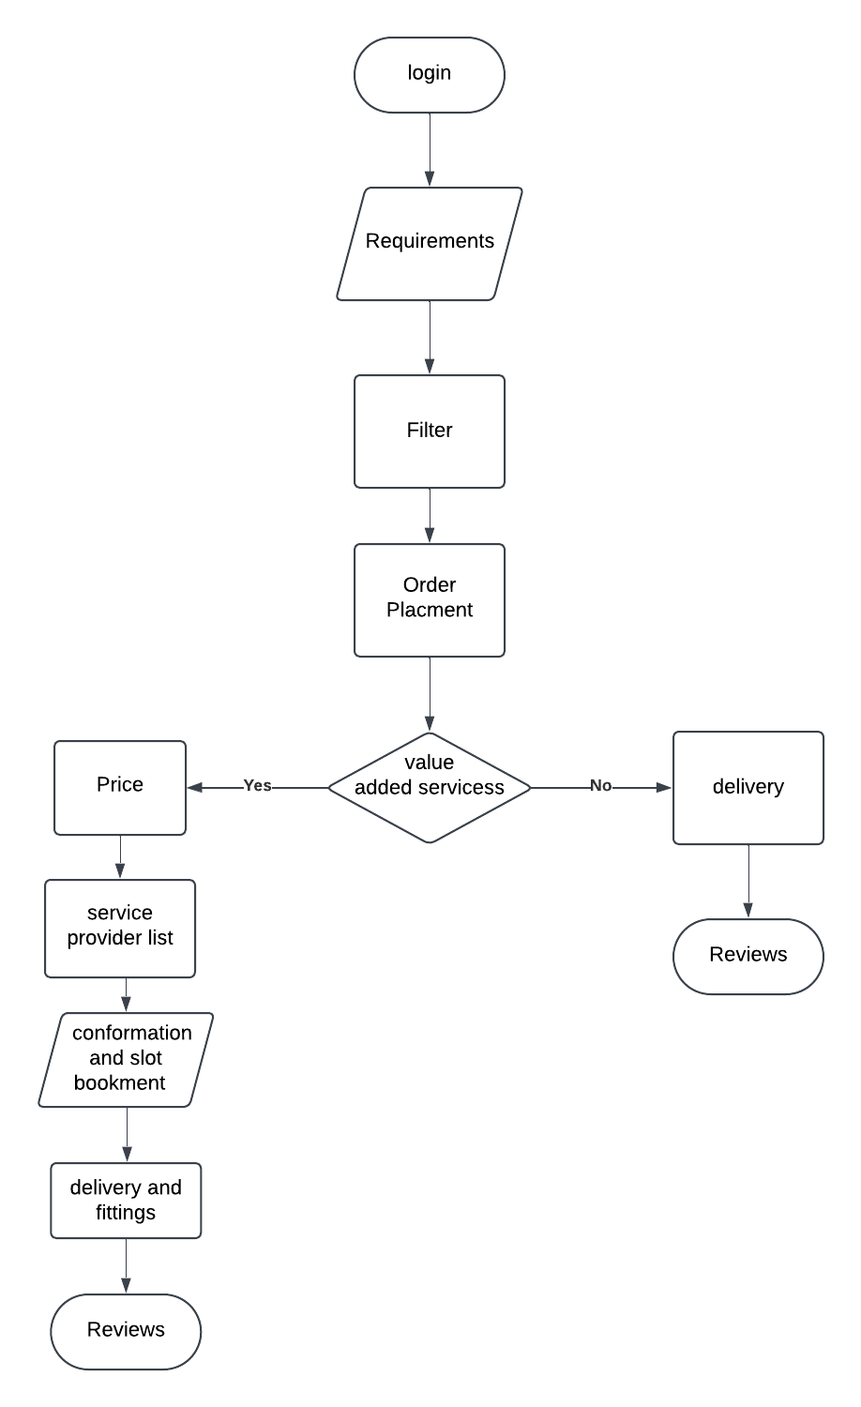

**Fig.2**

1. Login

* The users begin by logging in to the application.
* The step provides access to personalized recommendations, order history, and saved preferences.
* Strong security authentication methods (e.g., email, mobile number, or social login) are utilized.

2. Option of Need

* Customers select their need, and it can be:
* Their specific spare part they need.
* Their make and model of car in order to guarantee compatibility.
* Specific service, e.g., fitment, fixing, or swapping.

3. Filter Options

* In order to make searching simpler, customers are able to make use of filters, e.g.,
* Brand and Manufacturer – OEM against after-market spares.
* Price Range – Low or top-end price alternatives.
* Availability – Checking levels of availability.
* Location-Based Services – Discovery of service providers in the vicinity.
* The fourth step ensures the user is only presented with the most suitable alternatives.

4. Order Placement

* Once the user has decided, he or she proceeds to order.
* The order is either:
* A direct purchase of a spare part, where the user simply buys the part.
* An add-on order of purchase, where they also schedule installation or maintenance.

5. Value-Added Services Decision

Here, the app verifies if there is any added service needed:

If No (Direct Delivery Path):

* Spare part is delivered directly to the user.
* User gets the product and can give a quality and delivery service rating.

If Yes (Service Provider Path):

* User orders added services like installation, repair, or fitting.
* They proceed to the subsequent steps of service provider selection.

6. Price Estimation

* The cost and spare part cost is estimated and displayed by the app.
* Cost can be identified on:
* Difficulty of the installation.
* Rating and experience of the service provider.
* Variation of price with locality.

7. Selection of Service Provider

* A range of available workshops or service providers is revealed.
* Users may compare service providers based on:
* Rating and Reviews – Past customer reviews.
* Pricing – Competitive price rates.
* Location – Areas near service centers for convenience.
* Availability – Real-time or advance booking.
* Quality is guaranteed by the right provider.

8. Slot Booking and Confirmation

* User chooses a provider, and then slots are reserved to install.
* Confirmation is sent, and the service provider is notified.
* It allows convenient booking of slots at the right time.

9. Delivery and Fittings

* Delivery of spare parts to:
* User location, if he wishes to self-fit in it.
* The address of the service provider, if professionally appropriate.
* Installation as per the schedule assigned.

10. Reviews and Feedback

* The customers are requested to:
* Evaluate the quality of the spare part, after the service has been completed.
* Provide feedback on the service provider.
* Share their experience so others can learn.
* Positive reviews generate confidence and build credibility for the platform.

1. **SCOPE OF THE APP**

The Car Spare Parts and Service Provider App has been designed with the aim of connecting the car owners, spare part dealers, and service providers with the convenience of an easy online platform for spare part selling and booking of related services. The main objective of the app is connecting the inefficiencies of the conventional spare part purchasing and service booking processes with a structured and user-friendly process. The platform has been designed to be scalable, secure, and efficient in serving individual customers, automobile workshops, and spare part retailers.

One of the best aspects of the app is possessing a huge collection of spare parts for various car models, OEM as well as aftermarket. The customers are given the option to search for a specific spare part by entering corresponding details like the model of the car, brand, year of production, and type of part, thus enabling easy purchase of corresponding products. Additionally, the app has an even more advanced filter system, where the customers can filter the query on parameters like price, availability, brand, and rating, thus making it easy for them to make a decision.

Apart from spare part buying, the app also has a service booking platform through which consumers are able to reach out to authorized service providers and mechanics to do the installation, repair, and maintenance work. The feature is highly convenient as, apart from buying parts, consumers are able to order professional installation services at their convenience and location. The service provider module is also furnished with a review and rating feature, which allows customers to make informed choices based on customer reviews. The app also has price transparency as consumers are able to compare prices from multiple vendors and service providers in an attempt to get the best deal. In an attempt to make users even more convenient, the app has various options to finish orders, including home delivery, store pickup, and direct installations at service centers. A live order tracking system keeps the user informed about the status of their spare part orders and service bookings, thus making it more reliable and trustworthy. Apart from this, the app also has a secure payment gateway supported by various payment modes, including credit and debit cards, online banking, digital wallets, and cash-on-delivery, thus making it more flexible for the user.

For spare part dealers and vendors, the platform is a business platform for development with a user-friendly dashboard to manage stock, modify product descriptions, track orders, and engage with customers. Since it is vendor-agnostic, the app enables multiple vendors to register and post services, expanding the scope and reach of sales by different suppliers, workshops, and independent mechanics. The second important dimension of the scope of the application is its scalability and future growth potential. Although the main aspiration is to focus on automobile spare parts and services, the platform has been designed and developed with caution to act as the foundation for the support of possible future growth into bicycle spare parts, heavy vehicle parts, and other automobile-related services, including insurance, roadside assistance, diagnostics, and car history check. Such forward thinking is done in order to make the application future-proof and adaptable according to future business requirements of the industry. In short, the Car Spare Parts and Service Provider App is a smart and cost-saving method of digitalizing and streamlining car spare parts business. It offers more convenience, accessibility, and reliability as a one-stop shop for customers seeking original spare parts and professional services and, at the same time, generating business opportunities for service providers and suppliers. The overall and scalable plan ensures that the platform shall become an indispensable asset in the fast-growing automobile aftermarket market.

1. **CONCLUSION**

The Car Spare Parts and Service Provider App seeks to revolutionize the way car owners purchase spare parts and access related services. The app makes the process easier, smoother, and streamlined through the use of a structured workflow in the form of product filtering, price comparison, service provider selection, and instant booking. The major issue of the car sector is the lack of a single unified platform where authentic spare parts and original service points are provided altogether under one canopy for the customer. The activity going on is time-consuming in searching, variable charges, and unreliable services. This app addresses such challenges with an open and simple process for customers to choose the right spare part by vehicle fit, price, and brand preference, and where necessary, expert fitting advice. The provider module allows the customer to compare rating, stock availability, and pricing before booking a service. The app further provides safe payment, live tracking, and customer ratings, hence being very reliable and trustworthy. Through the bridging of the gap between car owners, service providers, and spare part suppliers, the website improves the accessibility of the service, the quality of services, as well as minimizing inefficiency in operations. The app's process-based approach is not only good for consumers but also for mechanics and spare part suppliers since it boosts their online presence even further. It is another means of going digital in the car spare parts and service business in an attempt to reach customers with quality products and services without any sort of difficulty or lack of transparency.

1. **REFERENCE**
2. A. Sharma and P. Verma, **"Automobile Spare Parts Marketplace: A Digital Approach,"** *International Journal of Emerging Technologies and Engineering Research (IJETER)*, vol. 8, no. 3, pp. 45-50, March 2023.
3. K. Patel, R. Kumar, and S. Nair, **"AI-Based Spare Parts Recommendation System for Vehicles,"** *International Conference on Intelligent Transportation Systems (ICITS)*, 2022.
4. M. Gupta and A. S. Reddy, **"E-commerce for Automotive Spare Parts: Challenges and Opportunities,"** *Journal of Automotive Engineering and Innovation*, vol. 5, no. 2, pp. 102-115, 2021.
5. N. D. Singh, P. Ramesh, and K. Iyer, **"Spare Parts Logistics and Service Optimization in the Automotive Industry,"** *International Journal of Logistics and Supply Chain Management*, vol. 9, no. 1, pp. 30-40, 2020.
6. R. Bose, **"Development of an Online Platform for Automotive Repair and Parts Procurement,"** *Proceedings of the International Conference on Digital Transformation in Automotive*, 2019.
7. J. K. Aggarwal and T. Banerjee, **"A Review of Digital Platforms for Vehicle Maintenance and Spare Parts Distribution,"** *International Journal of Smart Innovations in Automotive Technology*, vol. 4, no. 1, pp. 55-68, 2022.
8. H. Al-Hassan and M. Tariq, **"Blockchain Technology for Transparency in Spare Parts Supply Chain,"** *IEEE Transactions on Industrial Informatics*, vol. 17, no. 5, pp. 3421-3432, 2023.
9. `L. Wang and X. Zhao, **"Automotive Aftermarket E-Commerce: Trends and Business Models,"** *Journal of Business and Technology Innovations*, vol. 6, no. 4, pp. 78-92, 2021.